//////////////////////////////////////////////////////////////////////////////////////////////////////////

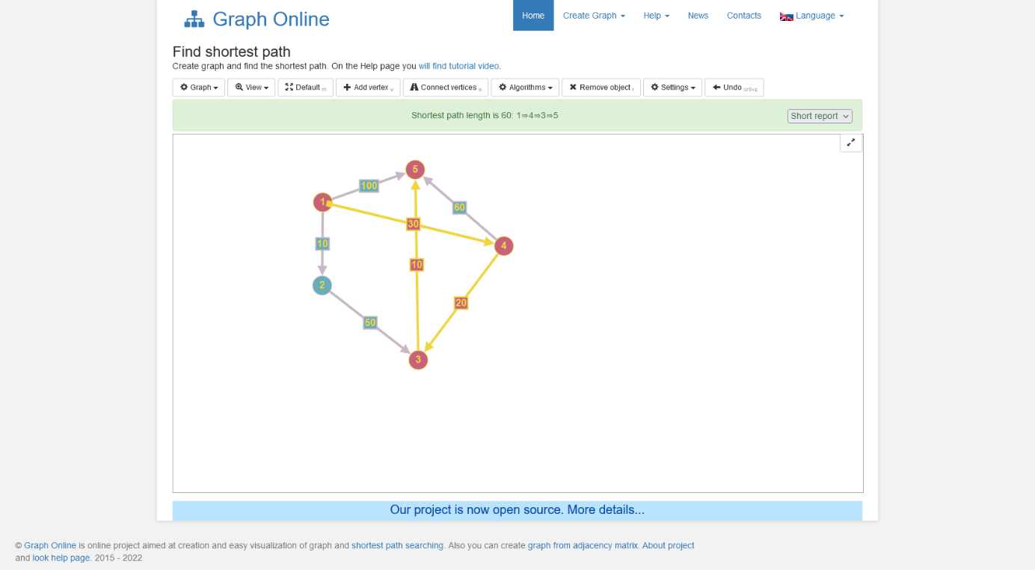

|  |  |  |  |  |  |  |  |  |  |
| --- | --- | --- | --- | --- | --- | --- | --- | --- | --- |
|  | Nr iter | S | ꙍ należy do V – S | D[1] | D[2] | D[3] | D[4] | D[5] |  |
|  | 0 | {1} |  | 0 | 10 | Inf | 30 | 100 |  |
|  | 1 | {1,2} | 2 |  |  | Inf vs 10+50 = 60 | 30 vs 10+inf = 30 | 100 vs inf = 100 |  |
|  | 2 | {1,2,4} | 4 |  |  | 60 vs 30+20 = 50 |  | 100 vs 30+60 = 90 |  |
|  | 3 | {1,2,4,3} | 3 |  |  |  |  | 90 vs 50+10 = 60 |  |
|  | 4 | {1,2,4,3,5} | 5 | 0 | 10 | 50 | 30 | 60 |  |
|  |  |  |  |  |  |  |  |  |  |
|  |  |  |  |  |  |  |  |  |  |

Optymalne koszty są w ostatnim wierszu

1<5

|  |  |  |  |  |  |
| --- | --- | --- | --- | --- | --- |
| v | 1 | 2 | 3 | 4 | 5 |
| P(v) | 1 | 1 | ~~1~~   ~~2~~  4 | 1 | ~~1~~   ~~4~~  3 |

1>4>3>5

//////////////////////////////////////////////////////////////////////////////////////////////////////////